Progress Report I

Team Members: Zhigang Su , Anna Doyel
Date: January 19, 2026

1. Who are the target audience that will be utilizing your final project?
- Beginners: The primary audience is students in introductory classes who are learning basic Linux commands and system concepts.
- Organizations: It also serves organizations or communities that currently check system status manually by logging into machines.
2. What tools/technologies will you be using to build your final project and why?
- Linux Shell Scripting: This is the core technology used to automate system health checks.
- Linux System Commands: We will use standard commands like top, df, and free to gather data.
- Platforms: The project will run on environments like Ubuntu, AWS, or VDI because they are easy to install and beginner-friendly.
- Why: These tools are simple, easy to understand, and do not require advanced software installations for an introductory class.
3. Provide any system architecture or infrastructure diagram.
- Data Collection: Shell script executes Linux commands (top, df, free).
- Processing: The script processes the raw data into a readable format.
- Output: The information is displayed on a menu-based interface and recorded into a log file.
4. What is the theme of your final project?
- The theme is Automation and Efficiency in System Health Monitoring.
- The project aims to replace slow, manual monitoring with a centralized, automated script.
5. What are the key features that will come in your final project?
- Resource Display: Real-time display of CPU, memory, and disk usage.
- System Uptime: Showing how long the system has been running.
- Logging: Saving system status to a file for performance history.
- User Interface: A simple menu-based or script-based interface for easy use.
6. How does your requirements for your final project satisfy end user needs?
- Early Detection: It helps users notice high CPU usage or low disk space before the system becomes too slow.
- Efficiency: It saves time by replacing manual command entry with automated scripts.
- Learning Tool: It provides a simple way for beginners to understand how Linux systems work.
7. What have you done for your final project?
- Planning: Completed the selection of system information to monitor.
- Research: Conducted research on the required Linux commands.
- Initial Scripting: Started writing the shell scripts to collect system data. 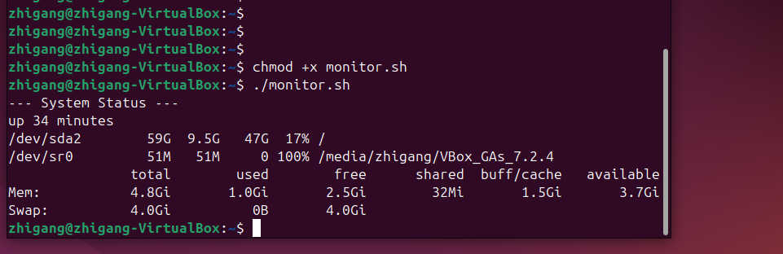
8. What is left to do in order to complete your final project?
- Complete Script Development: Finish the code for the menu interface and data integration (Expected by Jan 22).
- Testing and Debugging: Run the scripts to verify that all outputs are correct (Scheduled for Week 4).
- Final Documentation: Write all instructions and explanations for the project submission.

